**PETERSONS QUARRY DRAFT CONDITIONS**

|  |
| --- |
| SCHEDULE 2 |

**Reasons for Imposition of Conditions**

The conditions listed in this determination notice have been imposed to:

* Ensure compliance with the requirements of the *Environmental Planning and Assessment Act 1979*;
* Ensure compliance with the objectives of the Richmond Valley LEP 2012;
* Ensure satisfactory compliance with relevant Council plans, codes and policies;
* Prevent, minimise and/or offset adverse environmental impacts of the development;
* Set standards and performance measures for acceptable environmental performance to protect the existing and likely future amenity of the locality;
* Require regular monitoring and reporting;
* Maintain, as far as practicable, the public interest; and
* Ensure compliance with the Building Code of Australia and relevant Australian Standards.

**PART 1: CONDITIONS OF CONSENT**

**PART A: GENERAL**

**OBLIGATION TO MINIMISE HARM TO THE ENVIRONMENT**

1. In addition to meeting the specific performance measures and criteria established under this consent, the Applicant must implement all reasonable and feasible measures to prevent and/or minimise any material harm to the environment that may result from the construction, operation, or rehabilitation of the development.

**TERMS OF CONSENT**

1. The Operator shall carry out the development in accordance with the conditions of this consent and generally in accordance with the:
   1. Environmental Impact Statement (EIS) titled *Petersons Quarry* *Environmental Impact Statement* (Groundwork Plus, March 2022 Ref No. 2513 DA1 003 R1); and
   2. Supporting documents submitted with the EIS;
   3. Response to information request dated 13 February 2023 including EIS Addendum – Biodiversity, EIS Addendum – Rehabilitation, State Advice Letter, Surface Contamination Assessment
2. Stamped Approved Plans listed in Table 1:

*Table 1: Stamped Approved Plans*

|  |  |  |  |
| --- | --- | --- | --- |
| **Plan/Document Title** | **Drawing No.** | **Date** | **Prepared By** |
| Conceptual Site Layout Plan | 2513.DRG.026 Rev. 3 | 13/02/2023 | Groundwork Plus |
| Conceptual Final Landform | 2513.DRG.027 Rev. 1 | 07/12/2021 | Groundwork Plus |
| Conceptual Final Landform Cross Sections | 2513.DRG.027A Rev. 1 | 07/12/2021 | Groundwork Plus |
| Rehabilitation Management Plan | 2513.DRG.029 Rev. 2 | 08/11/2022 | Groundwork Plus |

1. If there is any inconsistency between the above documents, the most recent document shall prevail to the extent of the inconsistency. However, the conditions of this consent shall ultimately prevail to the extent of any inconsistency.

*Note: The Proposed Quarry Plan is included in Appendix 1.*

**SURRENDER OF EXISTING CONSENTS**

1. Prior to commencement, the following development consents are to be surrendered. A copy of the acknowledgment of surrender by the relevant Consent Authority is to be submitted to Richmond Valley Council:
   1. DA1985.0103 – Petersons Quarry
   2. SSD 7036 – Coraki Quarry

**OPERATIONS AS A SINGLE ENTITY**

1. The extractive industry is to be operated by a single entity and under a single Environmental Protection Licence.
2. The lots comprising each separate ownership must be consolidated so that only two separate parcels exist prior to commencement of operations. Easements shall be created as required at the time of consolidation.

**PUBLIC ROADS AND ADJOINING LAND**

1. Arrangements for the lease or closure of those parts of Petersons Quarry Road and Springhill Road affected by the proposal must be undertaken prior to commencement of operations.
2. The operator must not undertake any activity on the Crown land or use the Crown land for any purpose associated with the development, unless otherwise approved by the Crown.
3. The development is to be setback in accordance with the submitted plans excepting;
   1. a 10m setback is to be provided to any road reserve, and
   2. Setbacks to privately owned adjoining land shall be;
      1. A minimum of 10m or the line of existing vegetation whichever is the greater, or
      2. The existing excavated area shown on the approved plan, if lesser than 10m.

**LIMITS ON CONSENT**

**Quarrying Operations**

1. The Operator may carry out quarrying operations on the site for thirty years from the date that this consent becomes operative.

*Note: Under this consent, the Applicant is required to rehabilitate the site and carry out additional undertakings to the satisfaction of Council. Consequently, this consent will continue to apply in all other respects other than the right to conduct quarrying operations until rehabilitation of the site and those undertaking have been carried out to a satisfactory standard.*

**Production and Transportation Limits**

1. The Operator must not:
   1. extract more than 4,900,000 tonnes of quarry product from the site under this consent;
   2. extract to a depth below a level of RL 18m AHD in Lot 401 DP633427 and Lot 1 DP1225621;
   3. extract to a depth below a level of RL 17m AHD in Lots 402 and 403 DP802985, Lot 408 DP1166287, Lot A DP397946, Lot A DP389418, Lot 3 DP701197, Lot 2 DP954593, Lot 1 DP954592, Lot 1 DP310756, Lot 1 DP1165893 and Lot 1 DP1225621
   4. extract more than 350,000 tonnes of quarry products, in any financial year;
   5. transport more than 350,000 tonnes of quarry products from the site in any financial year;
   6. transport more than 35,0000 tonnes of products to the site in any financial year;
   7. transport more than 3960 tonnes of quarry products from the site per day;
   8. dispatch more than 110 laden trucks from the site per day;
   9. dispatch more than 10 laden trucks from the site per hour;
   10. accept more than 11 laden trucks carrying imported material to the site per day / per hour**.**
2. Heavy Vehicles are limited to the following truck and dog combinations:
3. 19m on Petersons Quarry Road, Lagoon Road & Dawson Street/Coraki Road, or
4. 26m truck and dog arrangement upon receiving an in-force permit from the National Heavy Vehicle Regulator (NHVR) specifically for this type of vehicle on the approved transport route. A copy of the in-force permit is to be provided to Council.

**Importation of Material**

1. The Operator may receive up to 35,000 tonnes (in total) of imported materials for use in blending/production of specialist quarry products in a financial year.
2. No materials classified as waste under the EPA *Waste Classification Guidelines 2014* (or its latest version) may be received and processed on the site.

*Note: This condition does not apply to routine deliveries of other materials to the site.*

**PRODUCTION DATA**

1. Prior to commencing operations, the Operator must engage a registered surveyor to carry out a baseline topographical survey to determine the footprint of the existing excavations and set the benchmark against which all other surveys will be compared.
2. The Operator must:
3. from the commencement of quarrying operations provide financial year annual quarry production data, verified by volumetric survey, including the volume of material excavated and volume of product stockpiles; and
4. include a copy of this data in the Annual Review.
5. All vehicles must be weighed on the weighbridge upon entry and exit, with a docket provided to the driver, and records kept by the quarry operator.
6. The operator is required to provide annual production data for the site to the Department of Regional NSW - Mining, Exploration and Geoscience, Geological Survey of NSW.

**IDENTIFICATION OF APPROVED EXTRACTION LIMITS**

1. Prior to commencing operations, unless otherwise agreed with the Council, the Operator must:
   1. engage a registered surveyor to mark out the boundaries of the approved limits of extraction within the site; and
   2. submit a survey plan of these boundaries with applicable GPS coordinates to the Council.
2. While quarrying operations are being carried out, the Operator must ensure that these boundaries are clearly marked at all times in a manner that allows operating staff to clearly identify the approved limits of extraction.

**OPERATION OF PLANT AND EQUIPMENT**

1. The Operator must ensure that all the plant and equipment used at the site, or to monitor the performance of the development is:
   1. maintained in a proper and efficient condition; and
   2. operated in a proper and efficient manner.

**DEMOLITION**

1. Any demolition work must comply with the provisions of AS 2601 - 2001 “The Demolition of Structures”.
2. Appropriate precautions shall also be taken to ensure compliance with the requirements of Safe Work NSW.
3. No approval is implied or granted for the construction, relocation or otherwise of any buildings or other facilities including any temporary structures. Separate approval shall be obtained as required.
4. The demolition and relocation of any electrical infrastructure within the site is to be undertaken in accordance with any requirements of Essential Energy.

**PROTECTION OF PUBLIC INFRASTRUCTURE**

1. Any damage caused to public infrastructure (roads, footpaths, kerb and gutter, stormwater, water and sewer mains, power and telephone services etc) during construction of the development/blasting shall be repaired to the satisfaction of Council. The repairs shall be carried out prior to the operation of the quarry under this consent.

Council shall be notified in writing, prior to commencement of works, of any existing damage to roads, stormwater drainage, kerb and gutter or footpaths.

Absence of notification signifies that no damage exists, and the applicant is therefore liable for the cost of reinstatement of any damage found at the completion of the works.

*Note: This condition does not apply to any damage to roads caused as a result of general road usage or otherwise addressed by contributions required under this consent.*

1. Existing 11kV and LV overhead power lines are located within the area of proposed works. The operator must;
   1. Ensure a minimum clearance area of 20.0 metres wide (or the easement width as noted on title) is maintained around the 11KV powerline (10m either side of the centreline of the powerline), or
   2. Relocate, or pay the full costs associated with relocating, any public infrastructure that needs to be relocated as a result of the development, and
   3. Ensure any works near the LV powerlines meets the requirements of the NSW Service and Installation rules, and
   4. Repair, or pay the full costs associated with repairing, any public infrastructure that is damaged by the development,

Any activities within the location of overhead electricity infrastructure must be undertaken in accordance with the latest industry guideline currently known as *ISSC 20 Guideline for the Management of Activities within Electricity Easements and Close to Infrastructure*. Approval may be required from Essential Energy should activities within the properties encroach on the electricity infrastructure.

**ROAD MAINTENANCE CONTRIBUTIONS**

1. A contribution under Section 7.11 (1)(b) of the Environmental Planning and Assessment Act 1979, amounting to $1.39 per tonne (rate as @ 13/6/2023) of material transported to and from the site is to be paid to Richmond Valley Council. Rates provided are correct at the time of this consent and are subject to variation annually based upon CPI*.*  Each payment must be:
   1. Paid to Council within two months of the end of each financial year; and
      1. Based on, weighbridge records of the quantity of quarry products and other approved materials transported to and from the site.

**SIGNAGE**

1. Prior to commencement of operations, the Operator must install a business identification sign at the property entrance, including phone number for registering complaints.

**CONTAMINATED LANDS**

1. Prior to operations commencing an Unexpected Findings Protocol (UFP) is to be prepared and implemented at the site. The UFP shall include measures specific to the following areas;
   1. The Temporary Waste Handling area identified in the Surface Soil Contamination Assessment dated August 22 prepared by Greencap, and
   2. any area previously used for fuel and/chemical storage and dispensing including the workshop and diesel fuel storage.
2. The UFP shall outline procedures including when a detailed site investigation in accordance with the NEPM (2013) is to be undertaken.
3. If remediation is required a Site Validation must be provided to Council prior to excavations commencing in the affected area.

**PART C: SPECIFIC ENVIRONMENTAL CONDITIONS**

**NOISE**

**Hours of Operation**

1. The Operator must comply with the operating hours set out in Table 2.

*Table 2: Operating Hours*

|  |  |  |
| --- | --- | --- |
| **Activity** | **Day** | **Time** |
| Extraction, processing, loading, dispatch and other quarry related activities | Monday to Friday  Saturday  Sunday & Public Holidays | 7:00am to 6:00pm  8:00am to 1:00pm  Nil |
| Blasting | Monday to Friday  Saturday  Sunday & Public Holidays | 9:00am to 3:00pm  Nil  Nil |

*Note: Maintenance and general pre-start activities may occur outside the hours specified in Table 1 provided they are inaudible at privately-owned residences.*

**Noise Criteria**

1. The Operator must ensure that the noise generated by the development on site does not exceed an LAeq(15 minute) daytime noise criterion of 40dB(A) at any residence on privately-owned land.
2. These criteria do not apply if the Operator has a written agreement with the relevant landowner/s to generate higher noise levels, and the Applicant has advised the EPA and Council in writing of the terms of this agreement.
3. The Operator must ensure that the noise generated by traffic from the development on public roads does not exceed an LAeq(1 hour) daytime noise criterion of 55dB(A) (external) at any residence on privately-owned land.

**Operating Conditions**

1. The Operator must:
   1. implement best management practice to minimise the construction, operational and traffic noise of the development,
   2. carry out noise monitoring (at least every 12 months) to determine whether the development is complying with the relevant conditions of this consent,
   3. regularly assess the results of noise monitoring to ensure compliance with the relevant conditions of this consent,

to the satisfaction of the Council.

**Noise Attenuation**

1. Where a written agreement, as set out in condition 35, is not obtained or is withdrawn, the Operator must adjust the scale of operations and/or activities, and undertake noise monitoring to ensure compliance with the Noise Criteria.
2. Prior to undertaking any noise mitigation, the Operator shall obtain an acoustic report from a suitable qualified and experienced acoustical consultant, outlining the measures proposed to be taken to achieve compliance to the satisfaction of Council and the EPA.
3. The Operator must implement any recommendations in accordance with the report and Council/EPA requirements.

**Noise Management Plan**

1. The Operator must prepare (and subsequently implement) a Noise Management Plan, in consultation with Council and the EPA, prior to commencement of operations. This plan must describe the measures that would be implemented to ensure:
   1. compliance with the noise criteria in this consent,
   2. best practice management is being employed;
   3. noise attenuation is implemented, where necessary; and
   4. a monitoring program is implemented to measure noise from the development against the noise criteria in this consent, and which evaluates and reports on the
      1. effectiveness of the noise management system onsite, and
      2. includes a protocol for determining exceedances of the noise criteria.

**BLASTING AND VIBRATION**

**Blasting Criteria**

1. The Operator must ensure that the blasting on the site does not cause exceedances of the criteria in Table 3.

Table 3 - Blasting Criteria

|  |  |  |  |
| --- | --- | --- | --- |
| ***Location*** | ***Airblast overpressure (dB(Lin Peak))*** | ***Ground vibration***  ***(mm/s)*** | ***Allowable exceedance*** |
| *Any residence on privately-owned land* | *120* | *10* | *0%* |
| *115* | *5* | *5% of the total number of blasts over a period of 12 months* |

1. However, these criteria do not apply if the Operator has a written agreement with the relevant owner/s or infrastructure provider/owner, and the Applicant has advised the EPA and Council in writing of the terms of this agreement.

**Blasting Frequency**

1. The Operator may carry out a maximum of two (2) blasts a month, unless an additional blast is required following a blast misfire.

**Operating Conditions**

1. During blasting operations, the Operator must implement best management practice to:
   1. protect the safety of people and livestock in the surrounding area;
   2. protect public or private infrastructure/property in the surrounding area from any damage;
   3. minimise the dust and fume emissions of any blasting; and
   4. operate a suitable system to enable the public to get up-to-date information on the proposed blasting schedule on site,

to the satisfaction of the Council.

**Blast Management Plan**

1. The Operator must prepare (and subsequently implement) a Blast Management Plan, in consultation with Council and the EPA, prior to commencement of operations. This plan must describe the measures that would be implemented to ensure:
   1. best management practice is being employed;
   2. the protection of road users and infrastructure when blasting within 500 metres of a public road; and
   3. compliance with the relevant conditions of this consent.

The Blast Management Plan must include:

1. a monitoring program for evaluating the performance of the development including compliance with the blasting criteria;
2. a protocol for temporary closure of any affected public roads and notification of emergency services and road users of a temporary closure;
3. community notification procedures for the blasting schedule;
4. an emergency response procedure in the event of flyrock; and
5. a protocol for investigating and responding to complaints.

**Dilapidation Report**

1. Within 3 months of commencing operations, the Operator must engage a suitably qualified engineer to prepare a dilapidation report detailing the structural condition of existing buildings and structures located within 1km of the maximum approved quarry pit footprint, if requested by the landowner and subject to safe access being provided by the landowner.

The Operator must write to the owners within 1km of the maximum approved quarry pit footprint to make them aware of this condition.

**AIR QUALITY**

**Air Quality Criteria**

1. The Operator must ensure that the particulate matter emissions generated by the development do not cause exceedances of the criteria in Table 4 at any residence on privately-owned land.

Table 4 – Air Quality Criteria

|  |  |  |
| --- | --- | --- |
| **Pollutant** | **Averaging Period** | **Criterion** |
| Particulate Matter <10 µm (PM10) | Annual | a 25µ/m3 |
| Particulate Matter <10 µm (PM10) | 24 hour | b 50µ/m3 |
| Particulate Matter <2.5 µm (PM2.5) | Annual | a8µ/m3 |
| Particulate Matter <2.5 µm (PM2.5) | 24 hour | b25µ/m3 |
| Total Suspended Particulates  (TSP) | Annual | ac90µ/m3 |
| Deposited Dust | Annual  (maximum increase) | a2 g/m2/month |
| Deposited Dust | Annual  (maximum total) | b4 g/m2/month |

*Notes for Table 4:*

1. *Cumulative impact (i.e. incremental increase in concentrations due to the development plus background concentrations due to all other sources).*
2. *Incremental impact (i.e. incremental increase in concentrations due to the development on its own).*
3. *Excludes extraordinary events such as bushfires, prescribed burning, dust storms, fire incidents etc.*

**Operating Conditions**

1. The Operator must:
   1. implement best management practice to minimise the dust emissions of the development including minimising the area of surface disturbance and maximising progressive rehabilitation of the site;
   2. regularly assess air quality monitoring data to ensure compliance with the relevant conditions of this consent; and
   3. minimise the air quality impacts of the development during adverse meteorological conditions;
   4. monitor and report on compliance with the relevant air quality conditions in this approval;

to the satisfaction of the Council.

**Air Quality Management Plan**

1. The Operator must prepare (and subsequently implement) an Air Quality Management Plan for the development in consultation with Council and the EPA, prior to commencement of operations. This plan must:
   1. Include the implementation of the dust control measures identified in section 4.6.2 of the Noise and Air Quality assessment prepared by MWA Environmental
   2. describe the measures to be implemented to ensure:
      * 1. compliance with the air quality criteria and operating conditions of this approval;
        2. best practice management is being employed; and
        3. the air quality impacts of the project are minimised during adverse meteorological conditions and extraordinary events;
   3. describe the proposed air quality management system;
   4. include an air quality monitoring program that:
      * 1. is capable of evaluating the performance of the project;
        2. includes a protocol for determining any exceedances of the relevant conditions of approval; and
        3. effectively supports the air quality management system.

**Meteorological Monitoring**

1. For the life of the development, the Applicant must ensure that there is a suitable meteorological station operating in the vicinity of the site that complies with the requirements in the Approved Methods for Sampling of Air Pollutants in New South Wales guideline.

**SOIL AND WATER**

**Water Supply**

1. The Operator must ensure it has sufficient water during all stages of the development, and if necessary, obtain water from a licenced supplier or adjust the scale of quarrying operations on site to match its available supply.

*Note: The Applicant is required to obtain any necessary water licences for the development under the Water Act 1912 and/or the Water Management Act 2000.*

**Water Discharges**

1. The Operator must comply with the discharge limits in any EPL which regulates water discharges from the site, or with Section 120 of the POEO Act.

**Topsoil**

1. Topsoils must be stored to allow for rehabilitation of the quarry at the cessation of use. The soils are to be stored in such a manner to prevent their erosion, such as by stormwater or wind.

**Soil and Water Management Plan**

1. Prior to commencement of operations, the Operator must engage a qualified consultant to develop a Soil and Water Management Plan (SWMP). The SWMP must be submitted to, and approved by, the EPA prior to extractive activities taking place. The SWMP must be prepared in accordance with Managing Urban Stormwater Soils and Construction, Volume 1 and Volume 2E. Mines and Quarries.
2. The Soil and Water Management Plan must be implemented for the life of the operation.

**Groundwater**

1. The Operator must monitor operations to ensure groundwater is not intercepted.

**TRAFFIC AND TRANSPORTATION**

**Traffic Management Plan**

1. At all times during construction and operation of the quarry, the Operator must implement a Traffic Management Plan prepared to the satisfaction of Council. The Traffic Management Plan must:
   1. Describe the processes in place for the management of trucks entering and exiting the site;
   2. Include by a Driver Code of Conduct, including but not limited to:
      1. Identification of the haulage route.
      2. A map of the vehicle movement plan highlighting critical locations.
      3. An induction process for vehicle operators and regular toolbox meetings.
      4. Procedures for travel through residential areas, school zones and/or bus route/s.
      5. A complaint resolution and disciplinary procedure.
      6. Community consultation measures proposed for peak extraction periods.
      7. Work, health and safety requirements under the *Work Health and Safety Regulation 2017*.
   3. Proposed measures to minimise the transmission of dust and tracking of material onto public roads from vehicles leaving the site.

**Road Upgrades**

1. Prior to commencement of operations of the quarry under this consent all internal access roads must be constructed to an all weather standard.
2. Any works affecting public roads must not take place without the prior approval of the roads authority.
3. Within 12 months of commencement of operations, the applicant must complete the following road works:
4. Construct the Lagoon Road/Dawson Street/Casino Coraki Road/Queen Elizabeth Drive intersection (Dawson Street intersection) to a sealed BAR/BAL intersection treatment.
5. Reconstruct and/or extend existing stormwater infrastructure at the Dawson Street intersection to suit the sealed BAR/BAL intersection treatment.
6. Re-line mark the Dawson Street intersection as advised in the recommendations in TTM’s Traffic Road Safety Audit dated May 2021.

If there is need to relocate any infrastructure or install any additional signage it must be undertaken as part of the works approved under the Section 138 Roads Act approval.

Design plans detailing the intersection construction works must be submitted to Richmond Valley Council with the Section 138 Roads Act application. Any activity or work in the road reserve can only occur following the issue of the Section 138 Roads Act approval by Richmond Valley Council.

1. A defects liability bond (in cash or Bank Guarantee) shall be lodged with Council. The date of Practical Completion shall be the date upon which all engineering works are completed and the defects liability bond has been paid. The bond shall be based on 10% of the value of the works which will become Council’s assets (Council’s adopted Revenue Policy (Fees and Charges)), and will be held by Council for a period of 12 months from the date of Practical Completion. The defects liability bond will be refunded at the satisfactory completion of the maintenance period (12 months). The bond shall only be released by advice from Richmond Valley Council that both the defects liability period has been completed, and that the works have been completed and are satisfactory at the end of the defects liability period.

The bond shall be paid to Council prior to Practical Completion.

1. A Civil Engineering assessment fee is to be paid to Council prior to the issue of a Section 138 Roads Act approval for the assessment of plans and inspection of civil works which will impact on or become Council’s assets. Rates are as detailed in Council’s Revenue Policy (Fees and Charges), with quantities assessed from approved plans detailing such civil works.
2. All construction work by private contractors in NSW, costing $250,000 or more, is liable for the payment of the Long Service Levy to the Long Service Levy Payments Corporation. Construction work includes civil construction such as roads and bridges, pipelines, fuel gas and water storage and distribution infrastructure, sewerage drainage and treatment systems, retaining walls, electrical distribution infrastructure, etc. Confirmation of the payment to the Corporation is to be submitted to Council prior to the issue of the Section 138 Roads Act approval.
3. Existing services/infrastructure which requires reconstruction or adjusting to suit a development (electricity, telecommunications, water, sewerage, stormwater, road works, kerb and gutter, footpaths, crossings and driveways, etc.) are to be carried out at the developer's expense. Construction is to be in accordance with Council’s standards, or the affected asset owners standards, and shall be completed prior to completion of the works detailed in Condition 61.
4. The Operator is to prepare and implement an Erosion and Sediment Control Plan in accordance with NSW Landcom’s “Managing Urban Stormwater Soils and Construction, 2004.These control measures shall be in place prior to the commencement of construction works and shall prevent soil erosion and transport of sediments from the development site into either:
   1. adjoining land
   2. natural drainage courses
   3. constructed drainage systems, and
   4. waterways

All control measures are to be maintained in an operational condition at all times during construction and until vegetation or permanent structures can satisfactorily control stormwater runoff. Control measures shall be regularly cleared of sediment and debris build-up, to ensure continued operation.

During construction works all motor fuels, oils and other chemicals are to be stored and used on site in a manner which ensures no contamination of stormwater. No incidents of visible pollution leaving the construction site. No litter placed in a position where it may be blown or washed off site.

1. Upon completion of works to be vested in Council, Work as Executed drawings and plans in digital format shall be submitted to and approved by Richmond Valley Council prior to the operation of the quarry under this consent. (AutoCAD or similar - changes as a separate layer in red). All work as executed plans shall bear the Consulting Engineer’s or Consulting Surveyor’s certification stating that all information shown on the plan is accurate. The plans shall clearly identify any amendments (in red) to the original design. The applicant shall be deemed to have indemnified all persons using such drawings against any claim or action with respect to breach of copyright.

All details shown in the Works as Executed drawings shall be in accordance with the Richmond Valley Council Works as Executed guidelines. The applicant is to submit a DWG file supporting the works as executed drawings for the ease of transfer of information in RVC’s GIS system.

1. Inspection and Testing covering all the necessary inspections and testing of the civil engineering works which will become Council’s assets (e.g. roads, kerb and gutter, stormwater drainage, water, sewer, footpaths, etc, or works which will impact on other infrastructure owners or adjoining properties e.g. inter allotment drainage lines and pits) shall be undertaken in accordance with the Northern Rivers Local Government Development and Design Manual and the Northern Rivers Local Government Construction Manual.

All relevant hold point inspections require Council attendance and acceptance of the work undertaken prior to the approval of the relevant hold point. If, for any reason, the hold point inspection is not accepted, works cannot proceed past the relevant hold point.

Relevant hold points for road works are to be carried out at the following typical stages (not all stages may be applicable):

* 1. Pre-construction - An initial inspection to assess proposed construction methods, trench standards, backfilling, trees to be removed, erosion and sediment controls, compulsory inspections, etc.
  2. Drainage works - including erosion and sedimentation controls
  3. CBR testing - to determine pavement depth and design
  4. Subgrade - includes inspection of subgrade, compaction testing, proof rolling etc
  5. Sub-Base layer - includes inspection of subbase, compaction testing, material test reporting, proof rolling etc
  6. Base layer - includes inspection of base, compaction testing, material test reporting, proof rolling etc
  7. Ball Peen testing and Benklman Beam testing
  8. Pre-approval of nominated mix design
  9. Sealing works (Primer Seal & AC)
  10. Line Marking
  11. Work as Executed plans
  12. Practical Completion
  13. End of maintenance period (12 months after Practical Completion)

All inspections will require a minimum of 48 hours prior notification to Council.

A copy of the Section 138 Roads Act approval, approved design plans, details and specifications must remain on site at all times during construction.

**Road Haulage**

1. The Operator must ensure that all loaded vehicles entering or leaving the site are covered at all times, except during loading and unloading.
2. The Operator must ensure that all loaded vehicles leaving the site are cleaned of materials that may fall on the road before they are allowed to leave the site.

**Monitoring of Product Transport**

1. The Operator must:
   1. keep accurate records of all laden truck movements to and from the site (hourly, daily, and annually); and
   2. confirm accurate records are being kept in the Annual Review; and
   3. retain that data for a period of 5 years and provide the data to the relevant authority upon request.

**ABORIGINAL CULTURAL HERITAGE**

1. The Petersons Quarry Expansion, Coraki NSW: Aboriginal Cultural Heritage Management Plan – Addendum V1 dated 3 May 2021 prepared by Eco Logical is to be appended to the existing Aboriginal Cultural Heritage Management Plan.
   1. A copy of the Plan is to be provided to Richmond Valley Council.
   2. Operations are to be undertaken in accordance with the plan.
2. The Aboriginal heritage exclusion areas are to be maintained and clearly mapped in all environmental management plans/strategies.
3. No Aboriginal objects may be harmed without an approval from Heritage NSWA under the National Parks and Wildlife Act 1974.
4. If any Aboriginal object(s) are discovered and/or harmed in, or under the land, while undertaking the proposed development activities, the proponent must;
   1. Not further harm the object(s),
   2. immediately cease all work at the particular location,
   3. secure the area so as to avoid further harm to the Aboriginal objects(s),
   4. notify heritage NSW as soon as practical providing any details of the Aboriginal objects(s) and its location,
   5. not recommence any work at the particular location unless authorised in writing by Heritage NSW.
5. If harm to Aboriginal objects cannot be avoided, an application for an Aboriginal heritage Impact Permit (AHIP) must be prepared and submitted to Heritage NSAW before work may continue.
6. In the event that skeletal remains are unexpectedly encountered during the activity, work must stop immediately, the area secured to prevent unauthorized access and NSW Police and Heritage NSW contacted.

**VISUAL AMENITY**

**Visual Amenity**

1. The operator must implement all reasonable and feasible measures to minimise the visual impacts of the development, including maintaining the bunds established on the site.

**Lighting Emissions**

1. The Operator must ensure any lighting installed at the premises complies with AS 4282: *Control of Obtrusive Effects of Outdoor Lighting.*

**WASTE MANAGEMENT**

1. The Operator must:
   1. minimise the waste generated by the development; and
   2. ensure that the waste generated by the development is appropriately stored, handled, and disposed of,
      1. All waste must be stored in a designated waste storage area and removed from the site to an approved waste disposal facility,
      2. Any waste storage area used for the storage of liquid wastes must be covered, have an impervious surface and be bunded to prevent the escape of spills and leaks.
   3. maintained the site in a tidy manner on site at all times,
   4. operate the on-site sewage management system in accordance with the approval to operate

to the satisfaction of the EPA and Council.

1. Burning of site refuse and materials is not permitted.

**LIQUID STORAGE**

1. The Operator must ensure that all tanks and similar storage facilities (other than for water) are protected by appropriate bunding or other containment, in accordance with the relevant Australian Standards.

**EMERGENCY AND HAZARDS MANAGEMENT**

**Dangerous Goods**

1. The Operator must ensure that the storage, handling, and transport of dangerous goods are conducted in accordance with the relevant Australian Standards, particularly AS1940 and AS1596, and the Dangerous Goods Code.
2. The operator must not store or transport hazardous materials above the relevant risk screening thresholds contained in guidelines to *State Environmental Planning Policy (Resilience and Hazards) 2021*.

**Safety**

1. The Operator must secure the development to ensure public safety.

**Bushfire Management**

1. The Operator must:
   1. ensure that the development is suitably equipped to respond to any fires on-site; and
   2. assist the rural fire service and emergency services as much as possible if there is a fire on-site.

**BIODIVERSITY AND REHABILITATION**

**Vegetation Removal**

1. Vegetation removal shall be limited to vegetation identified to be removed in the *Petersons Quarry Expansion Flora and Fauna Assessment* prepared by Eco Logical, dated 02/08/2021 V2.

**Rehabilitation**

1. The Operator must rehabilitate the site in a manner that is generally consistent with the conceptual final landform in Appendix 3 and comply with the objectives in Table 4, to the satisfaction of Council.

Table 4: Rehabilitation Objectives

|  |  |
| --- | --- |
| Feature | Objective |
| Lands associated with the development (as a whole) | * Safe, stable and non-polluting * Final landform integrated with surrounding natural landforms as far as is reasonable and minimize the visual impacts of the development when viewed from surrounding land. |
| Surface infrastructure | * Decommissioned and removed unless required for ongoing agricultural activities as agreed with Council. |
| Quarry benches and pit floor | * Revegetation using a combination of pasture species and native vegetation corridors which link other remnant vegetation on site. |

*Note: This condition is corresponding to condition 31 Schedule 3 of SSD consent notice as required by DPE*

1. The Operator must rehabilitate the lands associated with the development progressively, that is, as soon as reasonably practicable following disturbance. All reasonable and feasible measures must be taken to minimise the total area exposed for dust generation at any time. Interim stabilisation measures must be implemented where reasonable and feasible to control dust emissions in disturbed areas that are not active and which are not ready for final rehabilitation.

*Note: It is accepted that parts of the lands associated with the development that are progressively rehabilitated may be subject to further disturbance in the future.*

*Note: This condition is corresponding to condition 32 Schedule 3 of SSD consent notice as required by DPE*

**Biodiversity and Rehabilitation Management Plan**

1. The Applicant must prepare a Biodiversity and Rehabilitation Management Plan for the site to the satisfaction of the Council. This plan must:
   1. be prepared in consultation with Biodiversity Conservation Division (BCD), and be submitted to the Council for approval within 6 months of the date of this consent, or prior to the commencement of operations, whichever is earlier, unless the Council agrees otherwise;
   2. provide details of the conceptual final landform and associated land uses for the site;
   3. describe how the management of biodiversity would be integrated with the overall rehabilitation of the site;
   4. include detailed performance and completion criteria for evaluating the performance of the biodiversity management measures and rehabilitation of the site, including triggers for any necessary remedial action;
   5. describe the short, medium and long-term measures that would be implemented at the site;
   6. ensure compliance with the rehabilitation objectives, and the progressive rehabilitation obligations in this consent;
   7. include a program to monitor the effectiveness of these measures, and progress against the performance and completion criteria;
   8. identify the potential risks to the successful implementation of the plan and include a description of the contingency measures that would be implemented to mitigate these risks; and
   9. include details of who would be responsible for monitoring, reviewing, and implementing the plan.
   10. ensure compliance with the rehabilitation objectives, and the progressive rehabilitation obligations in this consent

The Applicant must implement the management plan as approved by the Council.

*Note: This condition is similar to condition 33 Schedule 3 of SSD consent notice as required by DPE*

**Rehabilitation Fund**

1. Within 6 months of the approval of the Biodiversity and Rehabilitation Management Plan, the Operator must lodge a Conservation and Rehabilitation Bond with the Council to ensure that the management of biodiversity and the rehabilitation of the lands associated with the development are implemented in accordance with the performance and completion criteria set out in the Biodiversity and Rehabilitation Management Plan.

The sum of the bond must be determined by:

* + - * 1. calculating the cost of rehabilitating the site, taking into account the likely surface disturbance over the next 3 years of quarrying operations; and
        2. engage a suitably qualified quantity surveyor or other expert to verify the calculated costs, to the satisfaction of the Council.

*Notes:*

* *If the rehabilitation of the site area is completed to the satisfaction of the Council, then the Council will release the bond.*
* *If the rehabilitation of the site is not completed to the satisfaction of the Council, then the Council will call in all or part of the bond, and arrange for the completion of the relevant works.*

*Note: This condition is corresponding to condition 34 Schedule 3 of SSD consent notice as required by DPE.*

1. Within 3 months of each Independent Environmental Audit the Operator must engage a suitably qualified quantity surveyor or other expert to review, and if necessary revise, the sum of the Rehabilitation Bond to the satisfaction of the Council. This review must consider the:
   * + - 1. effects of inflation;
         2. likely cost of rehabilitating the site (taking into account the likely surface disturbance over the next 3 years of the development); and
         3. performance of the implementation of the rehabilitation of the site to date.

*Note: In the event of sale of the land or change of operator, the bond must be transferred to the party liable for rehabilitation of the site and retained for the nominated purpose.*

**Quarry Closure Strategy**

1. At least 5 years prior to the cessation of quarry operations, the Operator must prepare a Quarry Closure Strategy for the development, to the satisfaction of Council. This strategy must:
   1. define the objectives and criteria for quarry closure;
   2. investigate options for the future use of the site, including any final void/s;
   3. describe the measures that would be implemented to minimise or manage the ongoing environmental effects of the development; and
   4. describe how the performance of these measures would be monitored over time.

**PART D: REPORTING**

**ENVIRONMENTAL MANAGEMENT STRATEGY**

1. Prior to commencement of operations, the Operator must prepare and implement an Environmental Management Strategy for the development taking into consideration any management and mitigation measures identified in the Environmental Impact Statement titled *Petersons* Q*uarry Environmental Impact Statement* (Groundwork Plus March 2022) including any additional information submitted and any management plans and monitoring programs approved under the conditions of this approval. The Strategy must:
   1. Provide the strategic context for environmental management of the project;
   2. Identify the statutory requirements that apply to the project;
   3. Describe the role, responsibility, authority and accountability of the key personnel involved in the environmental management of the project; and;
   4. Describe the procedures that would be implemented to:
      1. Keep the local community and relevant agencies informed about the construction, operation and environmental performance of the project;
      2. Receive, handle, respond to and record complaints;
      3. Resolve any disputes that may arise during the life of the project;
      4. Respond to any non-conformances;
      5. Manage cumulative impacts; and
      6. Respond to emergencies.

**ANNUAL REVIEW**

1. Prior to the end of August each year, the Operator must prepare and submit to Council an annual review detailing the environmental performance of the development. The annual review must:
   1. describe the development that was carried out in the previous financial year, and the development that is proposed to be carried out over the current financial year;
   2. include a comprehensive review of the monitoring results and complaints records of the development over the previous financial year, which includes a comparison of these results against:
      1. the relevant statutory requirements, limits or performance measures/criteria;
      2. requirements of any plan or program required under this consent; and
      3. the monitoring results of previous years.
   3. identify any non-compliance in the previous financial year, and describe what actions were (or are being) taken to ensure compliance;
   4. identify any trends in the monitoring data over the life of the development;
   5. identify any discrepancies between the predicted and actual impacts of the development, and analyse the potential cause of any significant discrepancies; and
   6. describe what measures will be implemented over the current financial year to improve the environmental performance of the development.

**INDEPENDENT ENVIRONMENTAL AUDIT**

1. Within one year of the commencement of any development under this consent, and every five years after the Operator must commission and pay the full cost of an Independent Environmental Audit (Audit) of the development. The Audit must:
   1. be led and conducted by a suitably qualified, experienced and independent team of experts whose appointment has been endorsed by Council;
   2. assess the environmental performance of the development and whether it is complying with the relevant requirements in this consent and any relevant EPL (including any assessment, plan or program required under these approvals);
   3. review the adequacy of any approved strategy, plan or program required under this consent;
   4. recommend appropriate measures or actions to improve the environmental performance of the development and any assessment, strategy, plan or program required under the abovementioned consent; and
   5. be conducted and reported to the satisfaction of Council.
2. Within three months of commencing an Independent Environmental Audit the Operator must submit a copy of the audit report to the Council, and any other NSW agency that requests it, together with its response to any recommendations contained the audit report, and a timetable for the implementation of the recommendations.

**ACCESS TO INFORMATION**

1. Within 1 month of the approval of any plan/strategy/program required under this approval (or any subsequent revision of these plans/strategies/programs), or the completion of any independent environmental audit or Annual Review, the Operator must provide a copy of the relevant document/s to Council.
2. The Operator must keep up-to-date copies of the following information available on site, at all times:
   1. the documents listed in condition 2 of this consent;
   2. approved strategies, plans or programs;
   3. a complaints register, which is to be updated on a quarterly basis;
   4. Annual Reviews (over the last 5 years);

any independent environmental audit.

**COMMUNITY ENGAGEMENT**

1. Prior to commencement of quarrying operations, the Operator must make available on its website;
2. a copy of this consent and any associated plans and strategies, and
3. details outlining how a member of the public can raise any complaints or issues directly to the quarry operator.

**PART E: INTEGRATED DEVELOPMENT GENERAL TERMS OF APPROVAL**

**General terms of approval for the NSW Environment Protection Authority issued pursuant to Section 4.46 of the Environmental Planning and Assessment Act 1979**

**(Insert EPA GTA’s dated 1 June 2023).**

**PART E: APPENDICES**

Appendix 1 – Proposed Quarry Plan

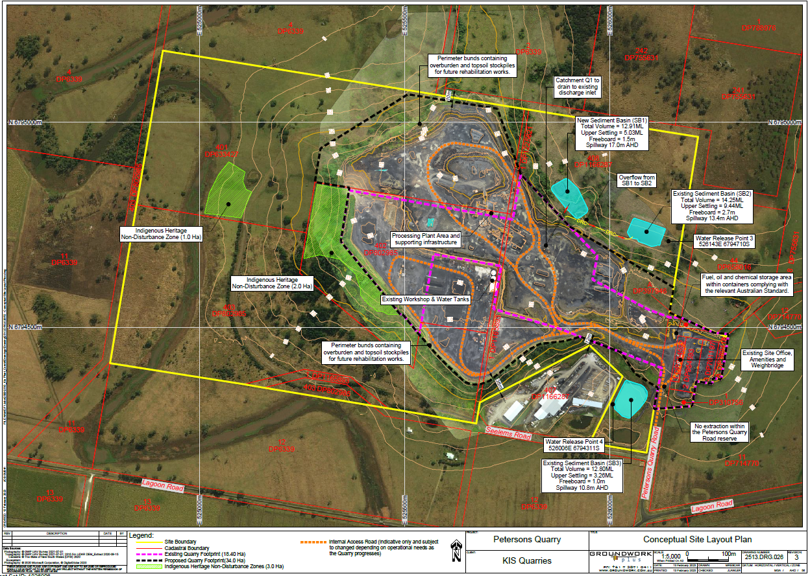

Appendix 2 – Noise Receiver Locations

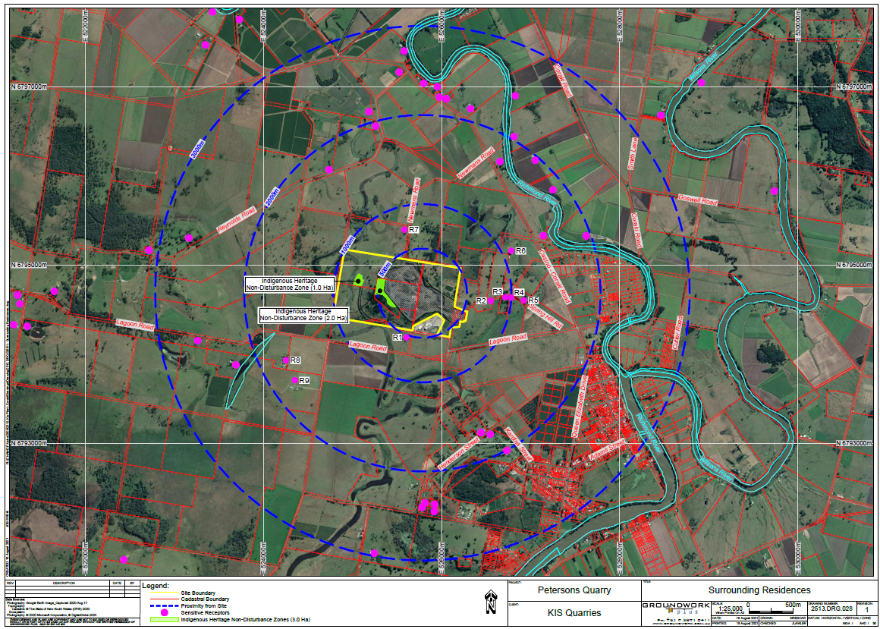

Appendix 3 – Conceptual Rehabilitation Plan

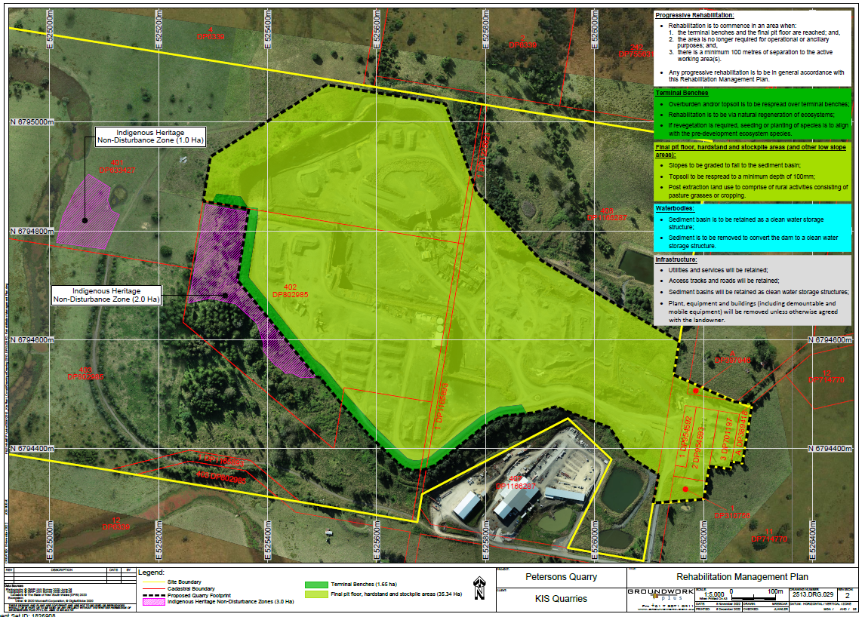

**INFORMATION TO APPLICANTS**

**ADVISORY NOTES**

**NOTE 1:** Prior to commencing any construction works, the following provisions of the Environmental Planning and Assessment Act, 1979 are to be complied with:

(i) A Construction Certificate is to be obtained from the Consent Authority or an Accredited Certifier in accordance with Section 6.7 of the Act.

(ii) A Principal Certifying Authority is to be appointed and Council is to be notified of the appointment in accordance with Section 6.6 of the Act.

(iii) Council is to be given at least two (2) days notice of the persons intention to commence building works, in accordance with Section 6.6 of the Act.

**NOTE 2:** The applicant may apply to the Council or an Accredited Certifier for the issuing of a Construction Certificate and to be the Principal Certifying Authority to monitor compliance with the approval and issue of any relevant documentary evidence or certificates.

**NOTE 3:** In accordance with Section 69 of the Environmental Planning and Assessment Regulation, it is a condition of Development Consent for development that involves any building work, that the work must be carried out in accordance with the requirements of the Building Code of Australia.

**NOTE 4:** If the provision of services or the construction of any infrastructure or any other thing required by this consent occurs, and a GST is payable by Council, the applicant will pay to the Council the GST (as defined below) which is payable by the Council in respect of this consent.

**NB:** GST means any tax levy charge or impost under the authority of any GST law (as defined by the GST Act) and includes GST within the meaning of the GST Act.

The GST Act means a New Tax System (Goods and Services Tax) Act 1999 or any amending or succeeding legislation.

**NOTE 5:** This development approval does not guarantee compliance with the Disability Discrimination Act and the developer should therefore investigate their liability under the Act. Council can assist developers by directing them to Parts 2, 3 and 4 of the Australian Standard 1428 – Design for Access and Mobility (Part 1 is mandatory in the BCA).

**NOTE 6:** The granting of the development consent does not negate the owner/applicant's obligations under Part 6 of the *National Parks and Wildlife Act 1974*, where it is declared an offence to harm, or desecrate, an Aboriginal object or declared Aboriginal Place. The Office of Environment and Heritage's *Due Diligence Code of Practice* should be used to determine whether harm is likely, and whether consent in the form of an Aboriginal Heritage Impact Permit (AHIP) is required.

**NOTE 7:** Underground assets may exist in the area that is subject to your application. In the interests of health and safety and in order to protect damage to third party assets please contact Dial before you dig at [www.1100.com.au](http://www.1100.com.au) or telephone on 1100 before excavating or erecting structures (This is the law in NSW). If alterations are required to the configuration, size, form or design of the development upon contacting the Dial before You Dig service, an amendment to the development consent (or a new development application) may be necessary. Individuals owe asset owners a duty of care that must be observed when working in the vicinity of plant or assets. It is the individual’s responsibility to anticipate and request the nominal location of plant or assets on the relevant property via contacting the Dial before you dig service in advance of any construction or planning activities.

**NOTE 8:** Telstra (and its authorised contractors) are the only companies that are permitted to conduct works on Telstra’s network and assets. Any person interfering with a facility or installation owned by Telstra is committing an offence under the Criminal Code Act 1995 (Cth) and is liable for prosecution.

Furthermore, damage to Telstra’s infrastructure may result in interruption to the provision of essential services and significant costs. If you are aware of any works or proposed works which may affect or impact on Telstra’s assets in any way, you are required to contact : Telstra’s Network Integrity Team on Phone Number 1800 810 443.

NOTE 9: Works within any part of the road reserve which will impact on pedestrians or traffic flow (including temporary site fencing which restricts pedestrian access, temporary disruption to traffic, etc) requires application under Section 138 of the Roads Act for approval to carry out any activity within the road reserve to Council. The application is to be made by the contractor proposing to carry out the activity in the road reserve prior to the commencement of the works in the road reserve.

The Section 138 Roads Act application is to be made via the NSW ePlanning Portal at <https://pp.planningportal.nsw.gov.au>.

In association with any Section 138 Roads Act application a Traffic Guidance Scheme (TGS) shall be prepared and submitted. Any TGS shall comply with Transport for NSW technical manual “Traffic Control at Work Sites” and shall be prepared by a person who is qualified, authorised and has passed a SafeWork NSW approved training course. The TGS designer’s certification number is to appear on the Traffic Guidance Scheme.

The Operator shall maintain all warning signs, lights, barriers and fences etc in accordance with the Traffic Guidance Scheme, Australian Standards and Work Cover guidelines. Safe public access around any works shall be provided at all times unless detailed in the Traffic Control Plan.

All contractors working within the road reserve are to have Public Liability Cover to a minimum value of $20,000,000. A certificate of currency is to be attached to any Section 138 Roads Act application to Council prior to the commencement of works.

Any advertising required to be undertaken by Council shall be at the developer’s cost.

The contractor shall not undertake any activity within the public road reserve until such time that a Section 138 Roads Act approval has been issued by Richmond Valley Council.

Any and all works approved under the Section 138 Roads Act application must be completed prior to commencement of operations under this consent.

**PRESCRIBED CONDITIONS OF DEVELOPMENT CONSENT**

Under the provisions of Section 69 of the Environmental Planning and Assessment Regulation for the purposes of Section 4.17(11) of the Environmental Planning and Assessment Act the following conditions are Prescribed Conditions:

1. All building work must be carried out in accordance with the provisions of the Building Code of Australia.

***Reason:***  *Required by Section 69 of the Regulation.*

2. In the case of residential building work for which the Home Building Act 1989 requires there be a contract of insurance in force in accordance with Part 6 of that Act, that such a contract of insurance is in force.

***Reason:*** *Required by Section 69 of the Regulation.*

3. Any Development that requires building work, subdivision work or demolition work a sign must be erected on the development site in a prominent position before the commencement of any work showing:

a) Name, address and telephone number of the Principal certifying Authority for the work.

b) Name of the Principal Contractor (if any) for any building work and a telephone number on which that person may be contacted outside working hours.

c) Stating that unauthorised entry to the work site is prohibited.

NOTE: The sign must be of rigid and durable material and maintained on the site until work has been completed. The sign must be easily read by anyone in any public road or public place adjacent to the site.

***Reason:*** *To ensure compliance with Section* 4.17(11) *of the Environmental Planning and Assessment Act, 1979 and Section 70 of the Accompanying Regulation.*

4. If the development involves an excavation that extends below the level of the base of the footings of a building, structure or work (including any structure or work within a road or rail corridor) on adjoining land, the person having the benefit of the development consent must, at the person’s own expense:

(a) protect and support the building, structure or work from possible damage from the excavation, and

(b) where necessary, underpin the building, structure or work to prevent any such damage.

The above requirements do not apply if the person having the benefit of the development consent owns the adjoining land or the owner of the adjoining land has given consent in writing to that condition not applying.

***Reason:*** *To ensure compliance with Section* 4.17(11) *of the Environmental Planning and Assessment Act, 1979 and Section 74 of the Accompanying Regulation.*